

Exam Centre Assignment

|  |  |  |
| --- | --- | --- |
| **Guided by Sikander Sir** | | |
| **Date** | **Version** | **Author** |
| 08-12-2022 | 1.0 | Saranya Munigolla  *Shwetha Julappayyanapalya Parashurama reddy*  *Lakshmi Durga Pippara*  *Senthamil Selvi A.P.*  *Geetanjali Sambana*  *Yalavarthi Sravya* |

## INDEX

1. Introduction
   1. Purpose 3
   2. Intended audience 3
   3. Intended use 3
   4. Scope 3
2. Overall description 3
   1. Assumptions and dependency 4
3. System feature and requirements 4
   1. Functions 4
      1. insertExamData**()** 4
      2. insertCandidateData**()** 4
      3. writeToFile() 4
      4. printHallTicket() 4
   2. System requirement 5
      1. Tools to be used 5
   3. System feature 5
4. Data Flow Diagram
   1. DFD level 0 6
   2. DFD level 1 6
5. Flow Chart 7

## Introduction: -

The introduction of the software requirement specification provides an overview of the entire software. The entire SRS with overview description purpose, scope, tools used and basic description. The aim of this document is to gather, analyze and give an in-depth insight into the complete exam center assignment application by defining the problem statement in detail. The detailed requirements of the exam center assignment application are provided in this document.

* 1. **Purpose**: **-** The purpose of this document is to show the requirements for the exam center assignment application, in which candidates will be assigned their exam center based on their exam information.
  2. **Intended Audience: -** This document is intended to be read by the client.

### Intended Use: -

* + - Development Team
    - Maintenance Team
    - Clients

Since this a general-purpose software any one can access it.

* 1. **Scope: -** This project aims to create the development of an exam center assignment application which takes the candidate information such as name, candidateID, examID, start date and end date and adds it to the database and returns the hall ticket with the information of the respective examination center of the candidate.

## Overall Description: -

It is an exam center assignment application which reads and stores the valid candidate data and the exam center data in a database. The application then correlates this data and assigns the respective exam center to the candidates based on the exam they will be appearing for.

The application will also store all the invalid entries in a text file and give the error message to the user.

Moreover, the application has the capability to generate a file which has the information of the candidates giving their exam in a particular exam center.

### Assumptions and Dependency: -

* + - System should have Ubuntu Linux installed.
    - System should have either 4GB or more RAM.
    - The service is used preferably on a desktop or laptop.

## System Features and Requirements: -

* 1. **Functions: -**
     1. **EC01-> insertExamData():** This function is the first function to be called when the application is called. It parses the exam center data from the text file and stores it in a linked list ready for further processing.
     2. **EC02-> insertCandidateData():** This function is used to insert candidate data while parsing it for the different fields and storing it in the list. Valid entries are tokenized and added to the list and the invalid entries are rejected and stored in a file whilst also giving the user an error message.
     3. **EC03-> writeToFile():** This function is used to assign the candidates their exam hall. It compares the values of the lists, which store only valid entries and then allocates the students their exam hall.
     4. **EC04-> printHallTicket():** This function prints the hall ticket when the user enters the candidate ID. If the candidate had entered the correct details, then they will get the hall ticket which has all the details about their exam and exam center.

## System Requirements: -

### Tools to be used:

* + - * System Programming
      * pthread library
      * Linux
      * C Programming
      * C File Handling
      * valgrind
      * make

## System Features: -

* + - Supportability: The system is easy to use.
    - Design Constraints: The system is built using only C language.
    - Usability: The exam center assignment application can be used to assign the appropriate exam center to a candidate based on the exams he wishes to attend on a particular date along with his credentials. The application is also able to generate the hall ticket containing Candidate ID, Exam ID, Candidate name, Name of college, address of exam center, start date, end date when the user enters their candidate ID.
    - Reliability and availability**:** The system is available 24/7 that is whenever the user would like to use the system, they can use it up to its functionalities.
    - Performance: The system will work on the user’s terminal**.**

## Dataflow Diagram:

### DFD Level 0 -

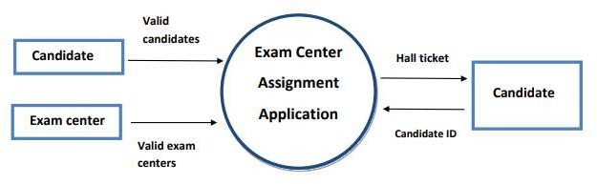

**4.1 DFD Level 1 –**

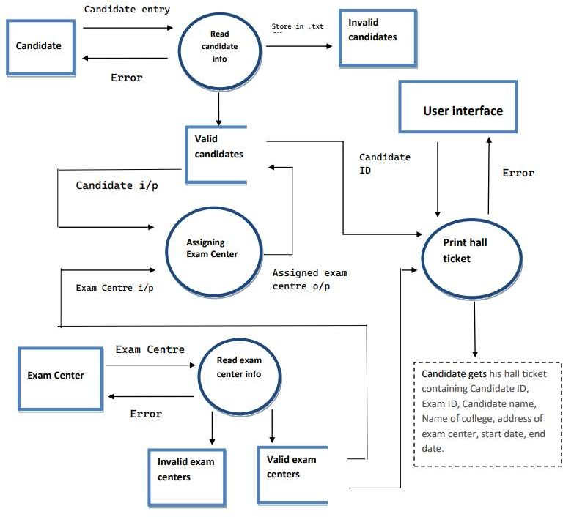

## Flow Chart:

